### **Assignment 2:** Produce a comparative infographic of TDD, BDD, and FDD methodologies. Illustrate their unique approaches, benefits, and suitability for different software development contexts. Use visuals to enhance understanding.

### **Here's a comparative infographic of TDD, BDD, and FDD methodologies:**

### **TDD (Test-Driven Development)**

* **Approach:** Write tests before writing code. Develop code to pass tests.
* **Benefits:** Ensures code reliability, reduces bugs, and improves design.
* **Suitability:** Suitable for projects needing high reliability and low defect rates.

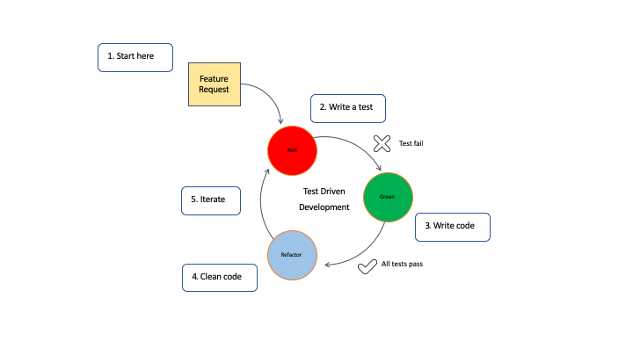

### 

### 

### 

### 

### **BDD (Behavior-Driven Development)**

* **Approach:** Define behavior in plain language. Write tests based on behavior. Develop code to meet defined behavior.
* **Benefits:** Improves communication among stakeholders, ensures code meets business requirements.
* **Suitability:** Best for projects requiring close collaboration between developers and non-technical stakeholders.

### 

### 

### 

### **FDD (Feature-Driven Development)**

* **Approach:** Plan and design features first. Develop features iteratively.
* **Benefits:** Focuses on delivering tangible features, improves project tracking.
* **Suitability:** Ideal for large projects needing detailed feature planning and iterative development.

